1.Introduction to Call and Put Options, Buyer and Seller Perspectives
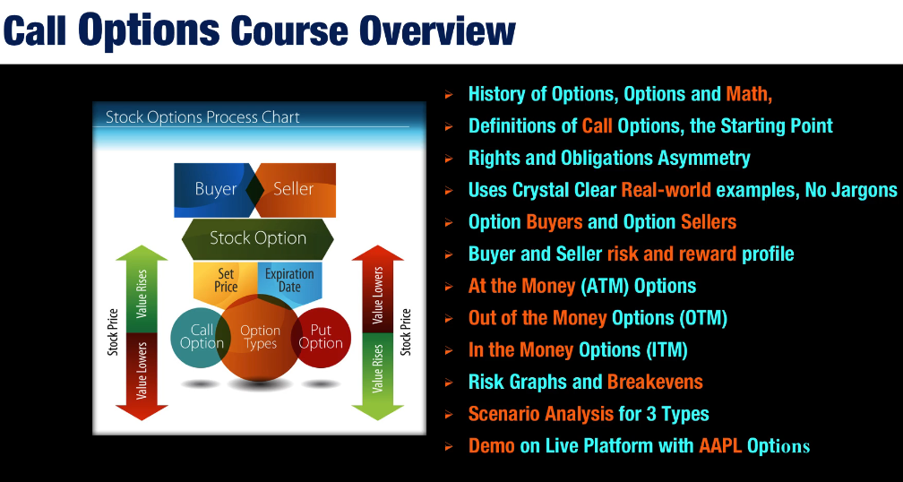

Introduction to Call Options

